UPPWISE INDIA

www.uppwise.com



**Quaterly Development Planning**

**Q1-2024**

**Feature: Hook creation on project import**

**Feature Title:**

Hook creation on project import

**Priority:**

Critical

**Submitted By:**

SPM

**Feature Description:**

The Project Upload Process is a streamlined mechanism that allows users to upload Excel files to create projects along with associated information.

Here in this feature majorly we are importing the customer specific excel through extention hook and we are not changing inside the current import functionalities.

**Target Users:**

Project Manager

Admin User

**Acceptance Criteria:**

The Project Upload Process is a streamlined mechanism that allows users to upload Excel files to create projects along with associated information. This efficient process simplifies the task of project initiation and ensures accurate and structured data input.

**Key Components:**

**Extention Hook:** We will create a new External Api where the logic for AXA will be added. And we will trigger this logic by the External hook.

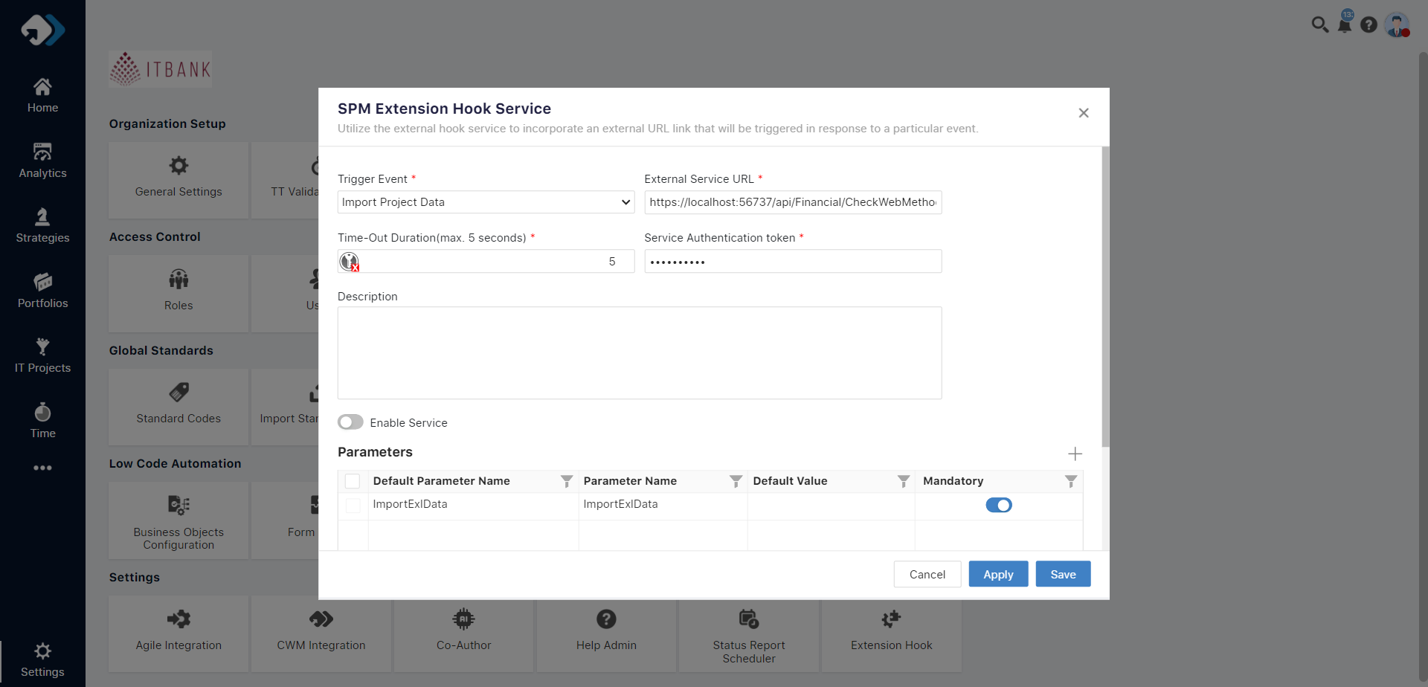

**Upload custom Excel File specific to the client requirement:**

* Users initiate the process by uploading an Excel file containing project details.
* The file acts as a comprehensive input document, capturing essential information for project creation.
* If hook will be enable then the below message will come over the popup (“This upload will be done by external service”)
* We can put the process in Async as there will be huge amount of data can get import at a time
* While click over the import one global flag will be raise that started and within this progress the project will be read only in the workspace. And one message wil be show over the workspace that “ the import is in-progress and due to this the project is in read only mode.”

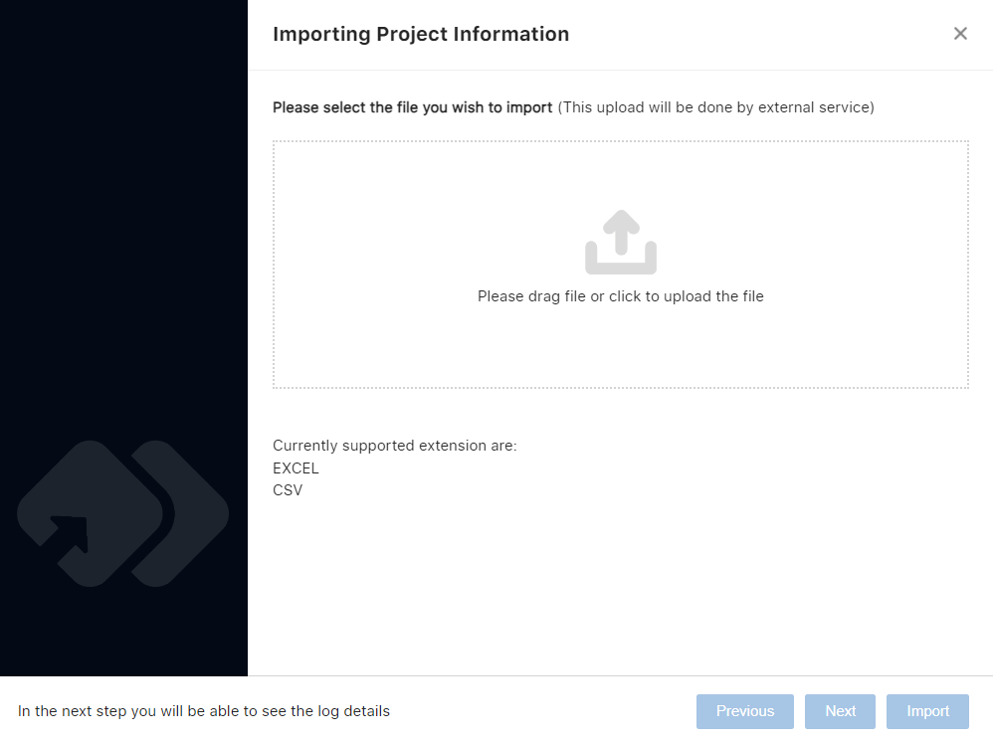

For the message after importing a file can vary based on the context and the purpose of the file. Here are some suggestions:

**Success Message:**

* "File successfully imported. You can now proceed with your tasks."
* "Import process completed. The file has been successfully uploaded."

**Confirmation Message:**

* "The file has been received and is under processing."
* "Thank you for submitting your file. We're now processing the data."

Note: Choose the message as per the preference and call it under the message control which we have in the application and can show over the popup .

**Log Details:**

After importing the file user can navigate the log details by clicking next button and check wether import created properly or not. And over the same data user have posibility to download the outcome in a excel format through the provided icon.

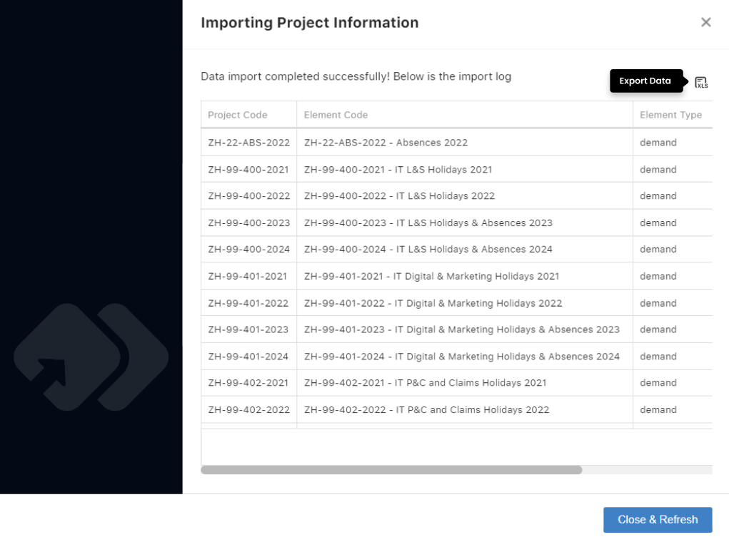

**Additional Note:**

When clicking on the "Import" option, a global flag will be raised indicating that the process has started. During this progress, the project will become read-only in the workspace. A message will be displayed within the workspace notifying users that "The import is in-progress, and due to this, the project is in read-only mode."

